Select one of the following projects and document your work with the following sections. Provide a brief description of the system and how you are designing it to operate.

A. Hardware Diagram:
Provide a hardware diagram of the components.
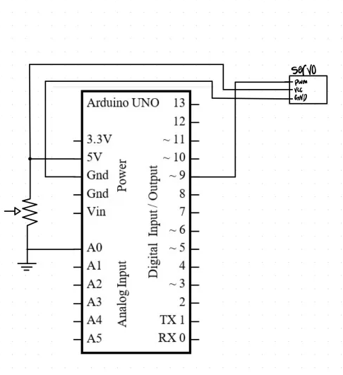
B. Program Flowchart:
Draw a flowchart of the program.
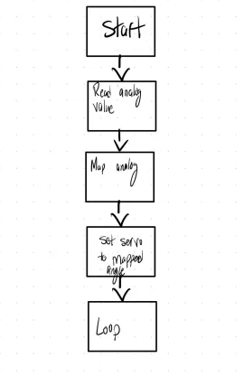
C. Arduino Source Code
Insert the Arduino Source Code into the document.
// ECE 2305 - Hardware Project 05

#include <Servo.h>

Servo voltmeterServo;
const int potPin = A0; // Potentiometer connected to A0

// Function to smooth noisy analog readings
int readStableAnalog(int pin) {
long sum = 0;
for (int i = 0; i < 10; i++) {
sum += analogRead(pin);
delay(1);
}
return sum / 10;
}

void setup() {
voltmeterServo.attach(9); // Servo connected to D9
}

void loop() {
int sensorValue = readStableAnalog(potPin); // Read stable analog value
int angle = map(sensorValue, 0, 1023, 0, 180); // Map 0–1023 to 0–180

static int lastAngle = -1;
if (abs(angle - lastAngle) > 5) { // Only update if angle changes > 2°
voltmeterServo.write(angle); // Move servo
lastAngle = angle;
}

delay(20); // Smooth motion, reduce jitter
}

D. Demonstration Video
Record and upload a video demonstrating the operation of the circuit. DONE

Save the document as a PDF file and submit the PDF document to Blackboard.

1. Servo Voltmeter

Program an Arduino board to accept an analog input voltage and display the magnitude of the voltage using a Hobby Servo to display the voltage. Use the servo horn to direct an arrow to the appropriate voltage. Provide as much precision in the display as possible.

